|  |  |  |
| --- | --- | --- |
|  |  | Lab 2 Report |
|  |  |  |
| William Beach  CDA3203 – Online Section  10/30/2022  Z23194964 |  |  |
|  |  |  |
|  |  | In lab 2, I’ve created a 1-bit half adder, 1-bit full adder, 4-bit full adder, 8-bit full adder, and 16-bit full adder circuit using only NAND gates. I’ve also utilized vector array notation and created a package of my components in order to abstract my VHDL code. This report includes the project settings, vector waveform files, VHDL code, and circuit drawings with only NAND gates (drawn using <https://app.diagrams.net/>) for each circuit. |

**1-Bit Half Adder Circuit**

|  |  |  |
| --- | --- | --- |
| Sum of Products  (Sum) :  F = AB’ + A’B  (Carry) :  F = AB |  | Scatter chart  Description automatically generated with medium confidenceGraphical user interface, table  Description automatically generated  Lab 2 Project settings 1-Bit Half Adder |
|  |  |  |
|  |  |  |
|  |  |

Vector Waveform Timing Diagram for 1- Bit Half Adder

**1-Bit Full Adder Circuit**

Sum of Products  
(Sum):

F = A’B’Cin + A’BC’in + AB’Cin’ + ABCin

(Carry):

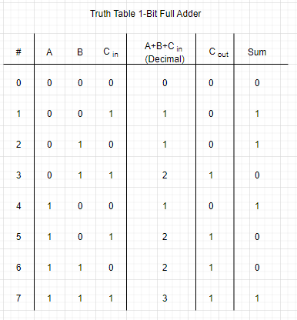F = BCin + AB + ACin

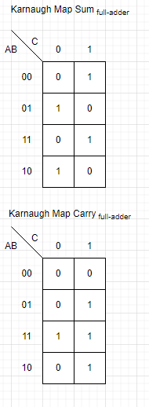

FullAdder Package that contains 1-Bit, 4-Bit, and 8-Bit Components

Lab 1 Project settings 1-Bit Full Adder

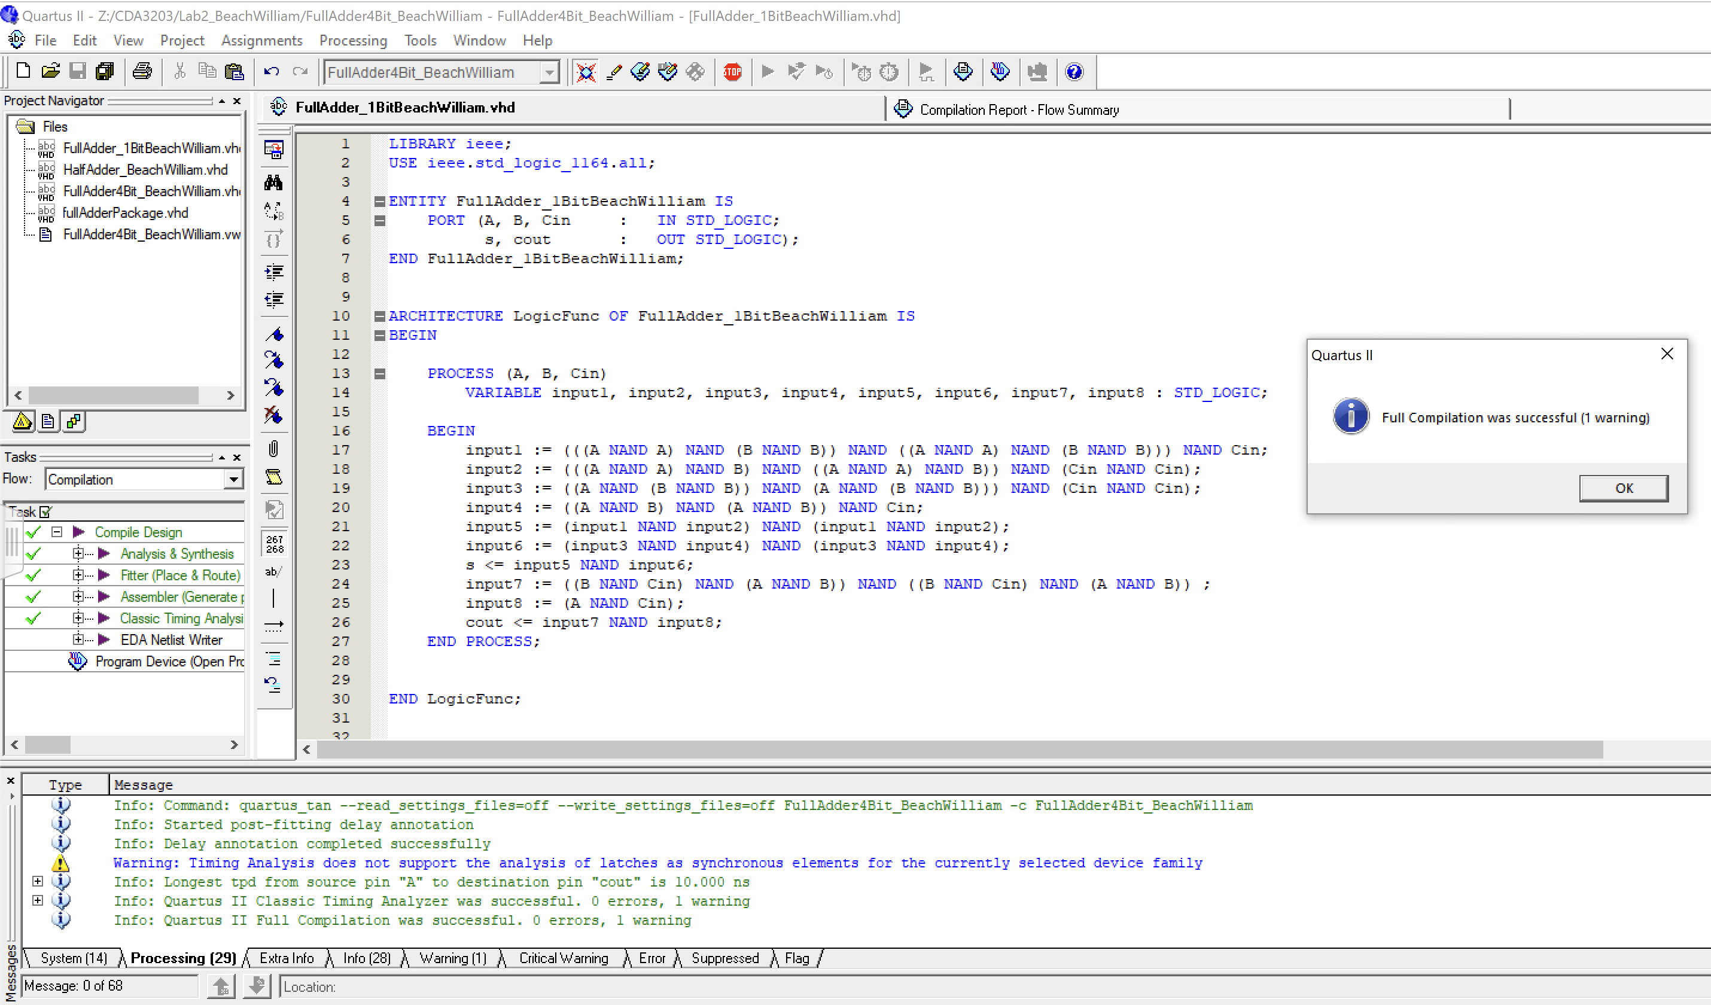

VHDL Code for 1-Bit Full Adder

Vector Waveform Timing Diagram for 1-Bit Full Adder

**4-Bit Full Adder Circuit**

VHDL Code utilizing package I made to contain full adder component

Lab 1 Project settings 4-Bit Full Adder

Vector Waveform Timing Diagram for 4-Bit Full Adder

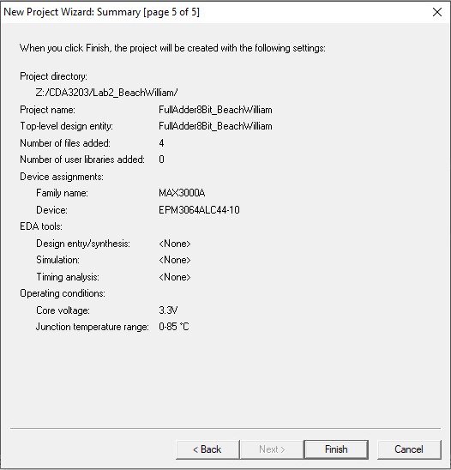

**8-Bit Full Adder Circuit**

Lab 1 Project settings 8-Bit Full Adder

VHDL 8-Bit Full Adder using 2 4-Bit Components synthesized in fullAdder package

**16-Bit Full Adder Circuit**

Vector Waveform Timing Diagram for 8-Bit Full Adder

Project settings 16-Bit Full Adder

Vector Waveform Timing Diagram for 16-Bit Full Adder

VHDL 16-Bit Full Adder

